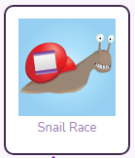
This week’s coding challenge is to code a snail and complete a snail race.
Follow the steps below to help you complete the task.
- Open up the Snail Race, you will find it in the 2Dos. 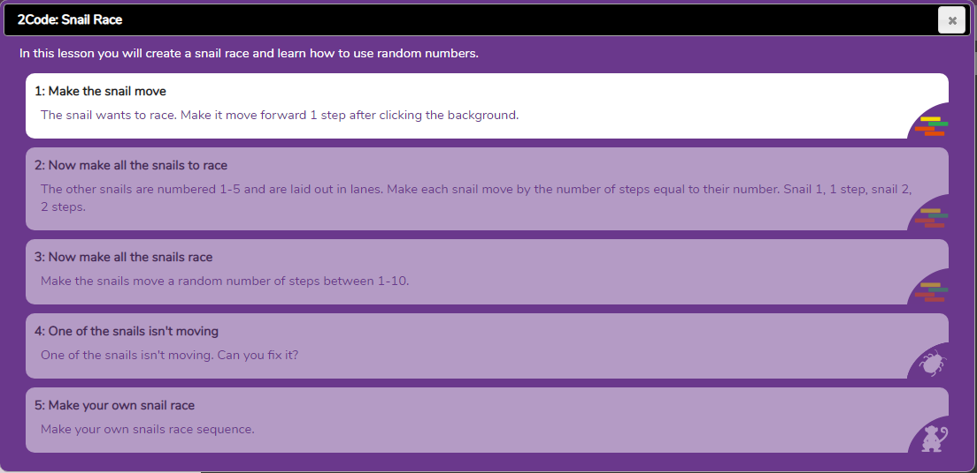

- Complete the first 4 tasks; you may want to play the videos to help you.
Task 5
- Open Task 5 – watch the video to help

- Go to design mode (top right corner)
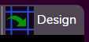
- Click and drag the different snails onto the start of the race. 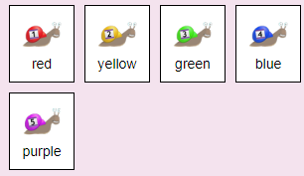
CHALLENGE: Make some snails big and some small, using the scale arrows. 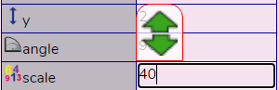

- Exit Design Mode, you should now be in Code Mode ready to code. 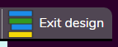

- Now start to code your snails to move
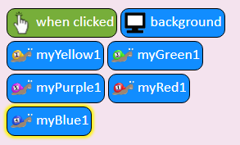

- You may want to use ‘when clicked’, the algorithm below will make the snail move 10 steps. Will the snail get to the end of the race or will you need to change the number of steps?
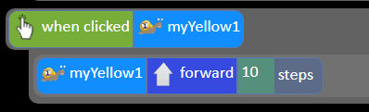

- You may want to make the snail move forward a random number of steps.
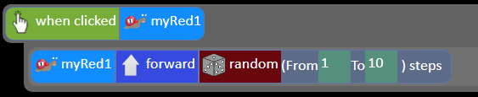

- Now run your code and see if it works. Think about if you need to make any changes to improve your work.

Don’t forget to save your work so your teacher can see what you have done!
- Click on the purple tab (top left corner) and Save
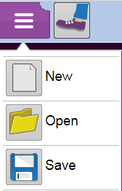

- Make sure you are saving in ’My work’ folder. You will need to be logged in for this.
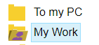

- Give your work a name – Turtle drawing and click Save

